Abstract— This report documents the design and implementation of the EliteFix Solutions website, a client-facing single-page application (SPA) built for a Dubai-based home maintenance and technical services company. The system is developed using Vue 3 with the Composition API, Vue Router for client-side navigation, and Pinia for state management. It presents the company's six core service lines—air-conditioning maintenance, plumbing, electrical work, general home maintenance, soil work, and media wall installation—through a componentized, reusable interface and provides prospective customers with multiple channels to request a quote, including a structured form and floating quick-contact buttons for WhatsApp and telephone. This report describes the overall system architecture, the component and routing structure, the technology stack, the implementation of key interactive features, and the rationale behind the chosen design patterns. The report concludes with an evaluation of the current implementation and recommendations for future enhancement, including backend integration and state-driven data management.
EliteFix Solutions: Design and Implementation of a Vue.js-Based Web Platform for Home Maintenance Service Delivery in Dubai
Mohsin Abid-037, M.Abubakar Siddique-084
Software Engineering
University of Sialkot, Pakistan
1230100374@uskt.edu.pk
Index Terms— Vue.js, Single-Page Application, Component-Based Architecture, Vue Router, Client-Side Rendering, Web Application Design.

INTRODUCTION
The growth of small and medium-sized service businesses in the United Arab Emirates has increased the demand for professional, mobile-friendly web presences that allow customers to browse services and request quotations without a phone call. EliteFix Solutions is a home maintenance and technical services provider operating across Dubai, offering air-conditioning maintenance, plumbing, electrical work, general home maintenance, soil work, and media wall installation. This report documents a web application developed for the company using the Vue 3 JavaScript framework.
The objective of the system is to present the company's services clearly, build customer trust through visible achievements and value propositions, and convert visitors into leads through an accessible quote-request workflow. The remainder of this report is organized as follows: Section II describes the system architecture, Section III details the technology stack, Section IV documents the component design, Section V describes the routing and page structure, Section VI discusses the implementation of key interactive features, Section VII presents the results, and Section VIII concludes with recommendations for future work.

SYSTEM ARCHITECTURE
The application follows a component-based, single-page application (SPA) architecture. A root component, App.vue, mounts the Vue Router outlet (RouterView) and a persistent FloatingButtons component that remains visible across all pages. Navigation between pages is handled entirely on the client side; the browser does not perform full page reloads when the user moves between routes.
The codebase is organized into four principal directories: components, which holds reusable and layout building blocks; views, which holds one component per route and composes the reusable building blocks into complete pages; router, which defines the path-to-view mapping; and stores, which holds Pinia state modules. This separation follows the conventional Vue 3 project structure and keeps presentational elements decoupled from page-level composition, which simplifies maintenance as new service pages are added.
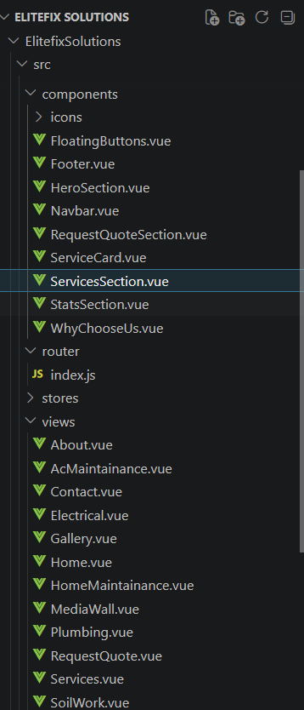Fig. 1. Project directory structure showing the components, views, router, and stores folders.

TECHNOLOGY STACK
Table I summarizes the technologies used across the presentation, routing, state, and styling layers of the application.
Layer | Technology | Role in the System
Core Framework | Vue 3 (Composition API, <script setup>) | Reactive UI rendering and component composition.
Routing | Vue Router 4 | Client-side navigation and path-to-view mapping (createWebHistory).
State Management | Pinia | Included and configured (counter store) for future application-wide state needs.
Iconography | Font Awesome (Free) | Social and action icons in the footer and floating buttons.
Styling | Scoped CSS (per-component <style scoped>) | Component-isolated styling, CSS Grid/Flexbox layouts, responsive breakpoints.
Build Tooling | Vite-based Vue 3 project structure | Module bundling and development server (standard Vue 3 scaffold).
TABLE I
Vue 3 was selected for its reactive, declarative rendering model and its Composition API, which allows related logic (such as the reactive form state in RequestQuoteSection.vue) to be grouped together within a single <script setup> block rather than spread across separate options. Vue Router was adopted for declarative, path-based navigation, and Pinia was scaffolded for centralized state management; at the time of this report, Pinia is configured but not yet used for shared application state beyond the default counter store generated by the project scaffold.

COMPONENT DESIGN
The interface is decomposed into ten reusable components, each responsible for a single section of the layout or a single piece of functionality. Table II lists each component together with its classification and responsibility.
Component | Type | Responsibility
Navbar.vue | Layout | Top information bar and sticky main navigation with a hover-activated Services dropdown; renders on every page.
Footer.vue | Layout | Site-wide footer with company summary, quick links, service links, and contact details.
FloatingButtons.vue | Utility | Draggable floating WhatsApp/call action buttons, mounted once in App.vue for the whole application.
HeroSection.vue | Presentational | Landing banner with headline, call-to-action buttons, and trust indicators.
ServicesSection.vue | Presentational | Homepage grid summarizing the six core services, each linking to its dedicated page.
ServiceCard.vue | Reusable / props-driven | Generic card that accepts title, icon, image, description, and link as props and emits a view-service event.
WhyChooseUs.vue | Presentational | Grid of value-proposition cards (certified technicians, fast response, pricing, etc.).
StatsSection.vue | Presentational | Achievement counters (projects completed, clients served, technicians, years of experience).
RequestQuoteSection.vue | Form / stateful | Embedded quote-request form using a reactive() object bound to name, phone, email, service, and message fields.
TABLE II

Reusable, Props-Driven Components
ServiceCard.vue is the only component in the system designed for external configuration through Vue's props/emits contract. It declares five props—title, icon, image, description, and link—using defineProps(), and emits a custom view-service event through defineEmits() when the "Learn More" button is clicked, delegating the navigation decision to the parent component. This pattern demonstrates the intended reusable-component approach for the system, although the homepage services grid (ServicesSection.vue) and the full services page (Services.vue) currently render their own inline card markup with a hardcoded services array rather than instantiating ServiceCard.vue directly.

Layout and Utility Components
Navbar.vue and Footer.vue are rendered independently within each view rather than being wrapped around RouterView in App.vue, giving each page control over whether they appear. FloatingButtons.vue is the only globally mounted component; it maintains its screen position using Vue's ref() reactivity and implements pointer-drag behavior through native mousedown/touchstart, mousemove/touchmove, and mouseup/touchend event listeners, allowing the user to reposition the WhatsApp and call buttons anywhere on the viewport.

ROUTING AND PAGE STRUCTURE
Client-side routing is configured in src/router/index.js using Vue Router's createWebHistory() mode, which produces clean URLs without a hash fragment. Twelve routes are registered, covering six primary navigation pages and six individual service detail pages, one for each of the company's service lines. Table III lists the complete route map.
Path | View Component | Purpose
/ | Home.vue | Landing page composed of Hero, Services, WhyChooseUs, Stats, and Quote sections.
/about | About.vue | Company story, mission and vision, and reused marketing sections.
/services | Services.vue | Full listing of all six services with descriptions and links.
/gallery | Gallery.vue | Categorized portfolio of completed project images.
/contact | Contact.vue | Contact information and embedded quote-request form.
/request-quote | RequestQuote.vue | Dedicated multi-field quote submission form.
/services/ac-maintenance | AcMaintainance.vue | Detailed page for the AC maintenance service.
/services/plumbing | Plumbing.vue | Detailed page for plumbing services.
/services/electrical | Electrical.vue | Detailed page for electrical services.
/services/home-maintenance | HomeMaintainance.vue | Detailed page for general home maintenance.
/services/soil-work | SoilWork.vue | Detailed page for soil work and excavation.
/services/media-wall | MediaWall.vue | Detailed page for media wall design and installation.
TABLE III
Each of the six service detail views (for example, AcMaintainance.vue and Plumbing.vue) follows a consistent internal structure: a Navbar, a service-specific content section, and a shared RequestQuoteSection embedded at the bottom of the page to encourage conversion. This repetition across views represents an opportunity for further componentization, discussed in Section VIII.
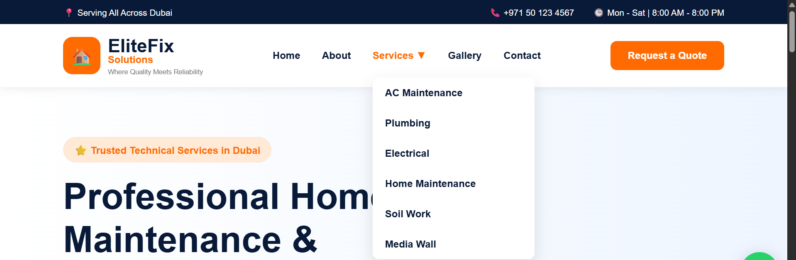Fig. 2. Sticky navigation bar with hover-activated dropdown listing all six services.

IMPLEMENTATION OF KEY FEATURES

Homepage Composition
Home.vue (Fig. 3) composes six components in sequence—Navbar, HeroSection, ServicesSection, WhyChooseUs, StatsSection, and RequestQuoteSection followed by Footer—demonstrating the system's page-as-composition pattern, in which a view file contains little to no markup of its own and instead arranges pre-built sections.
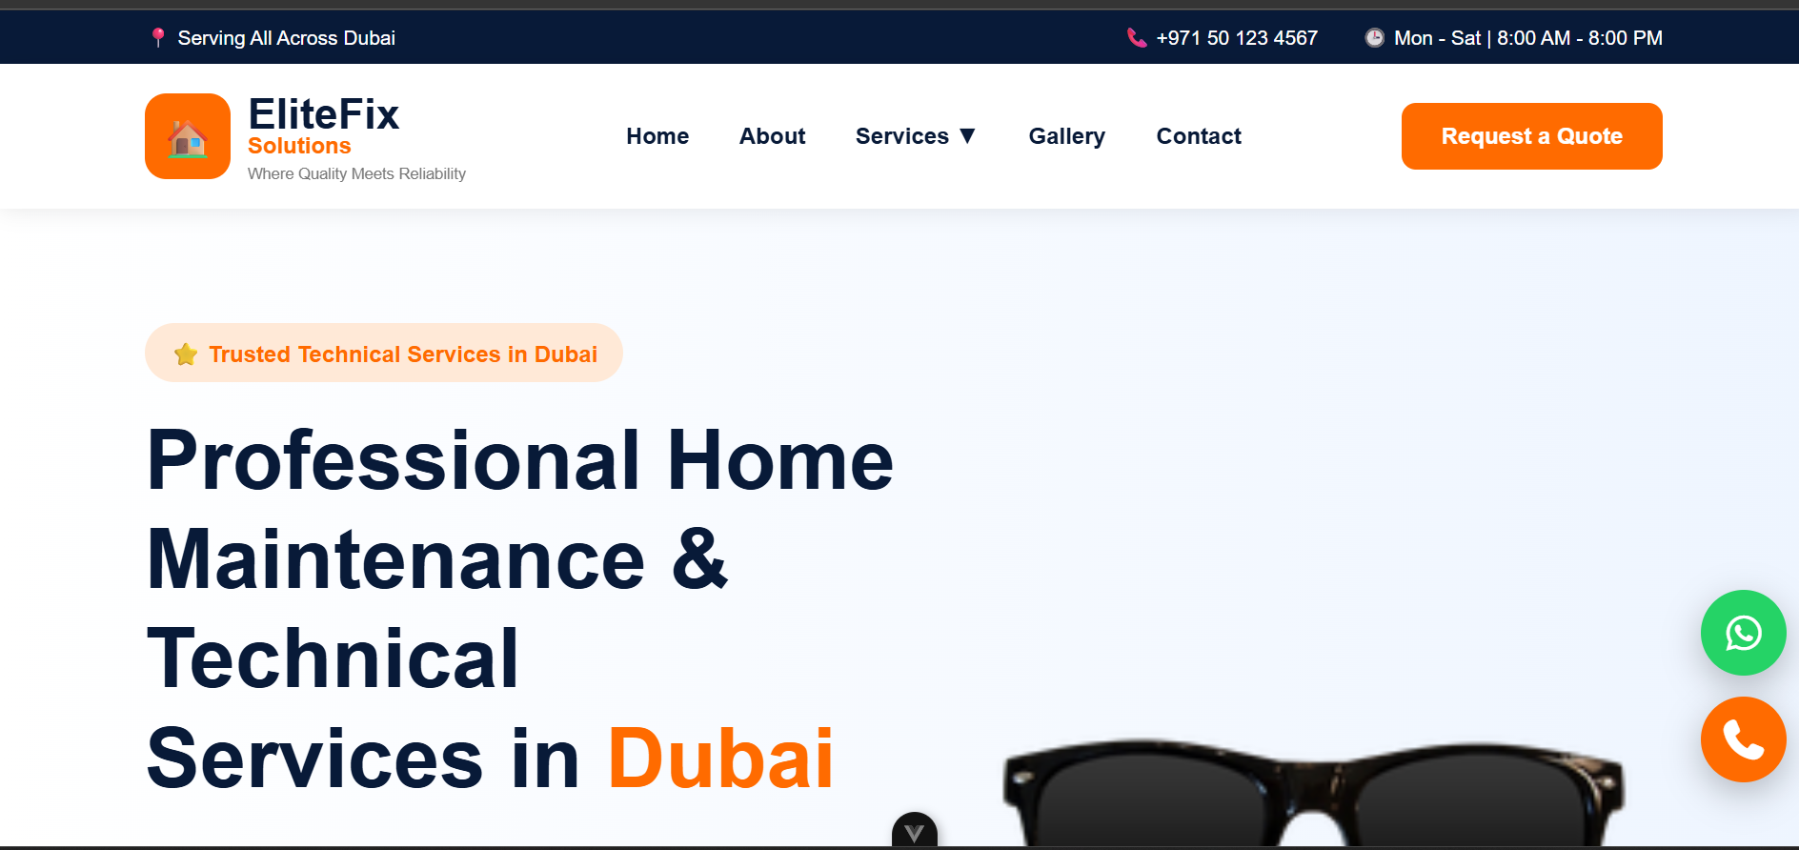Fig. 3. Homepage composed of the Hero, Services, Why-Choose-Us, Stats, and Quote sections.

Quote Request Workflow
Two independent quote-request forms exist in the system: an embedded form within RequestQuoteSection.vue (used on the Home, About, Services, Gallery, and Contact pages) and a dedicated, more detailed form on the RequestQuote.vue page, which adds a location field. Both forms use Vue's reactive() function to bind form fields—name, phone, email, service, and message—directly to input elements via v-model, and both currently log the submitted data to the console and, in the case of RequestQuote.vue, display a confirmation alert, in place of a live backend endpoint.
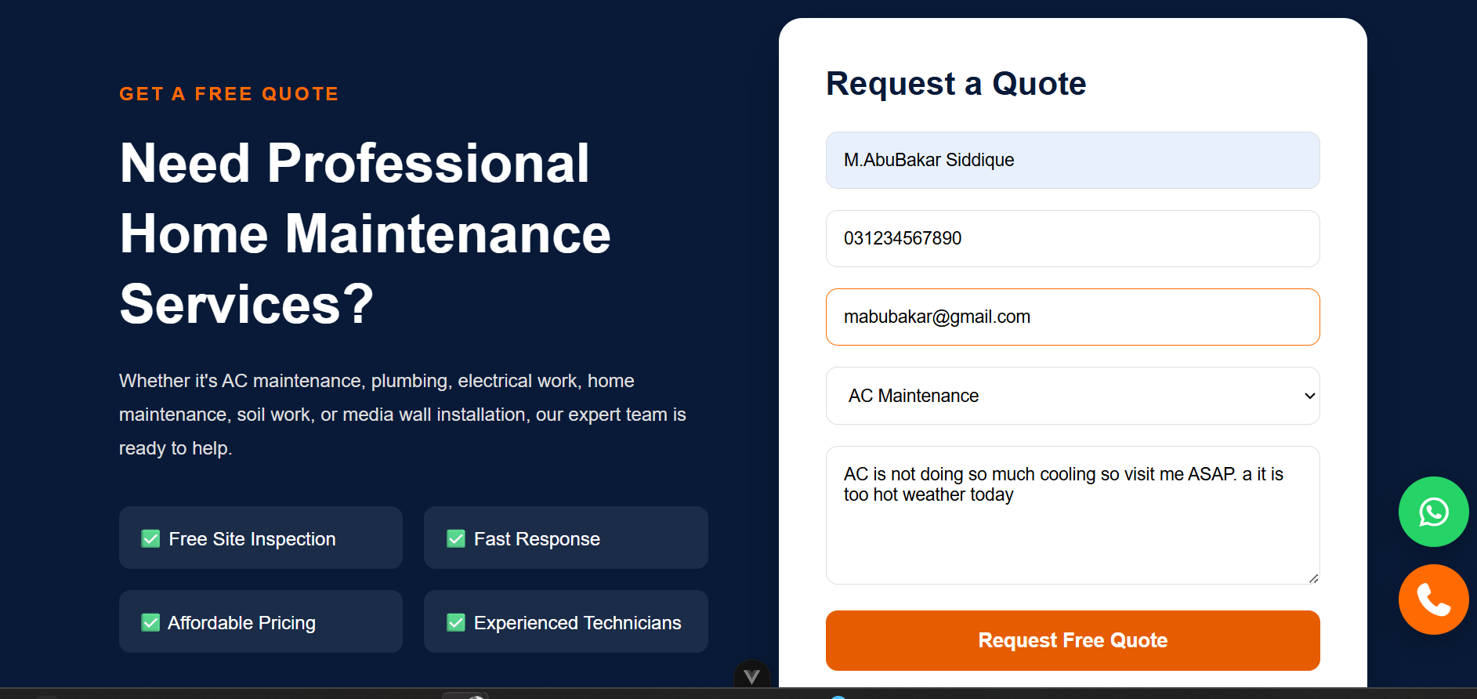Fig. 4. Quote-request form showing bound input fields and the service selection dropdown.

Gallery Page
Gallery.vue iterates over a static, in-component array of twelve project entries using v-for, each tagged with a title, category, and image path, allowing completed work to be showcased by service category (Air Conditioning, Plumbing, Electrical, Home Maintenance, Soil Work, and Media Wall).
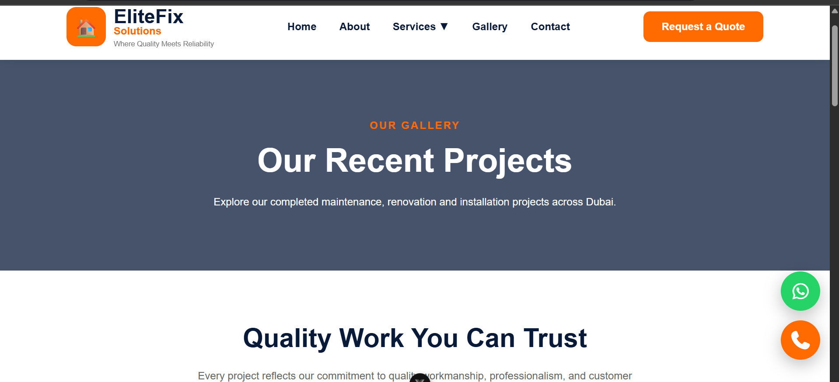Fig. 5. Portfolio gallery grouped by service category.

Floating Contact Buttons
The FloatingButtons component persists across every route because it is mounted at the App.vue level, outside RouterView. It renders a WhatsApp deep link (wa.me) and a tel: hyperlink for one-tap calling, and its position is draggable via pointer and touch event handling, allowing users on any page to reach the company without scrolling to the footer.

RESULTS
The resulting application delivers a fully navigable, responsive marketing and lead-generation website covering six service categories across twelve routes. All pages share a consistent visual identity, established through a common color palette (navy #081A38 and orange #FF6B00), consistent card and section patterns, and a shared Navbar/Footer/Quote-section structure. Responsive breakpoints, implemented with CSS media queries at 992px and, in select components, 600px, adapt multi-column grids to single-column layouts for tablet and mobile viewports.
Fig. 6. Responsive layout collapsing to a single column below the 992px breakpoint.
At the current stage of development, form submissions and service data are handled entirely on the client side: the services, gallery entries, and testimonial-style statistics are hardcoded arrays within each component's <script setup> block, and form submissions are logged to the browser console rather than sent to a server. The Pinia store is present in the project scaffold but not yet used to manage shared state such as submitted quotes.

CONCLUSION AND FUTURE WORK
This report has described the architecture, technology stack, and component design of the EliteFix Solutions website, a Vue 3 single-page application built to market a Dubai-based home maintenance company and generate customer leads. The system successfully demonstrates component-based UI composition, declarative client-side routing across twelve pages, and reactive form handling, all implemented with scoped, self-contained CSS per component.
Several improvements are recommended for future iterations of the system:
- Connect the RequestQuoteSection and RequestQuote forms to a live backend API (for example, a Node.js/Express endpoint, as anticipated by comments already present in the source code) so that quote requests are persisted rather than logged to the console.
- Replace the hardcoded services, gallery, and statistics arrays with data fetched from a content management system or database, enabling non-technical staff to update content without editing source files.
- Adopt the existing ServiceCard.vue component within ServicesSection.vue and Services.vue to eliminate duplicated card markup and enforce a single source of truth for card presentation.
- Utilize the Pinia store that is already scaffolded in the project to manage shared state, such as quote-submission status or fetched service data, across components.
- Add client-side form validation feedback and loading/success states to the quote-request workflow to improve usability once a real backend is connected.
Implementing these recommendations would move the system from a static, presentation-focused prototype toward a fully data-driven production application while preserving the component architecture already established.

REFERENCES
[1] Vue.js Documentation, "Introduction," Vue.js, [Online]. Available: https://vuejs.org/guide/introduction.html
[2] Vue Router Documentation, "Getting Started," [Online]. Available: https://router.vuejs.org/
[3] Pinia Documentation, "Introduction," [Online]. Available: https://pinia.vuejs.org/
[4] Font Awesome, "Font Awesome Free," [Online]. Available: https://fontawesome.com/

 

